Lab 9: Reflection and refraction of light
Name: Farooq Ahmodu
PSY 2001

Objectives:

The main objective of this experiment is to determine the refractive index values for mystery materials A and B and to prove that refraction angle follows from Snell’s equation
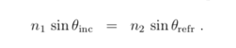

Procedure:
https://phet.colorado.edu/sims/html/bending-light/latest/bending-light_en.html
- Select “More tools"
- Play around with the simulation and report your observations.
- Check “Angles” to view the angle values.
- Set the 2nd material to water and plug the values you obtained for θ into the Snell’s equation from theory to see if you get the same n₂ value.
- Find n₂ values for mystery materials A and B.

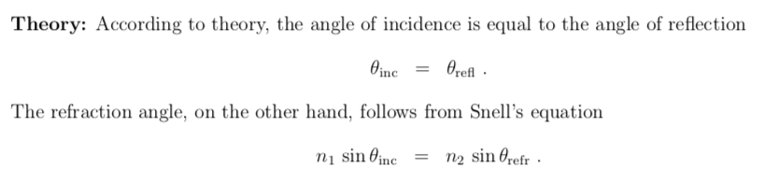
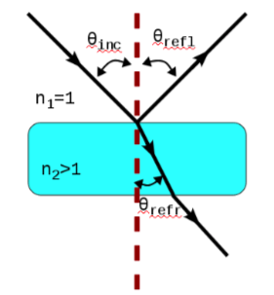
n₁=1 because air is very dilute and nearly the same as vacuum.

Experimental Data:

Air and Glass
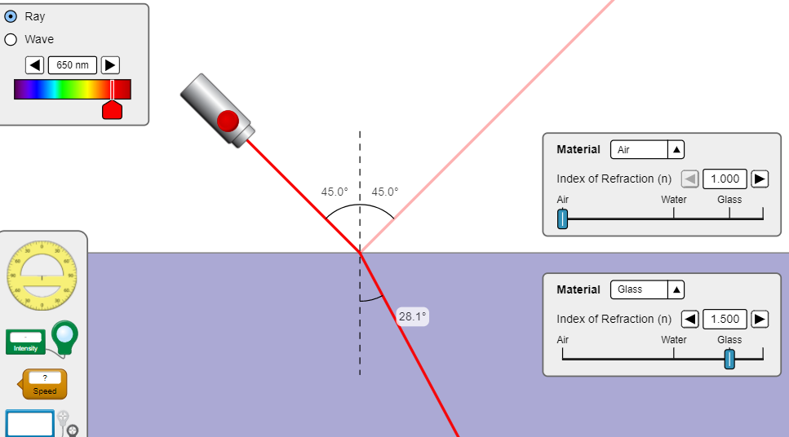

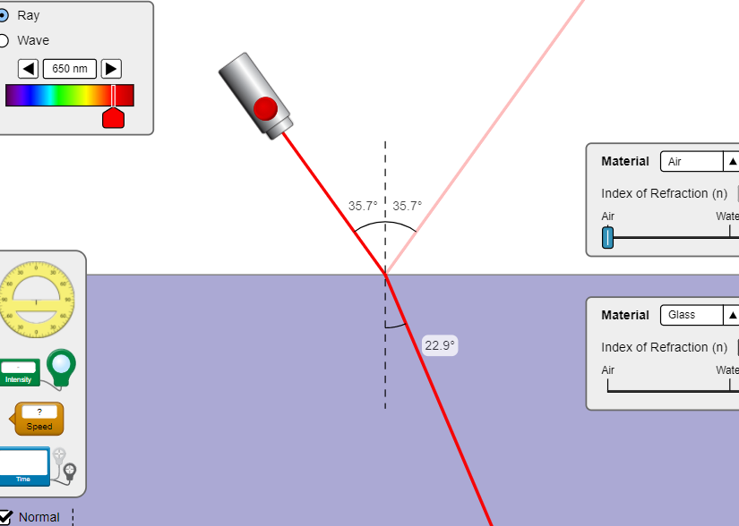

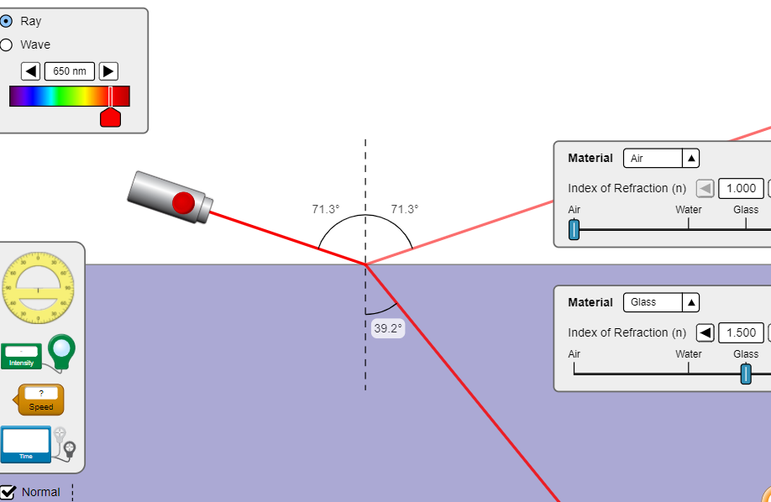

Incident angle | Angle of Reflection | Angle of refraction
45 | 45 | 28.1
35.7 | 35.7 | 22.9
71.3 | 71.3 | 39.2
Air and water

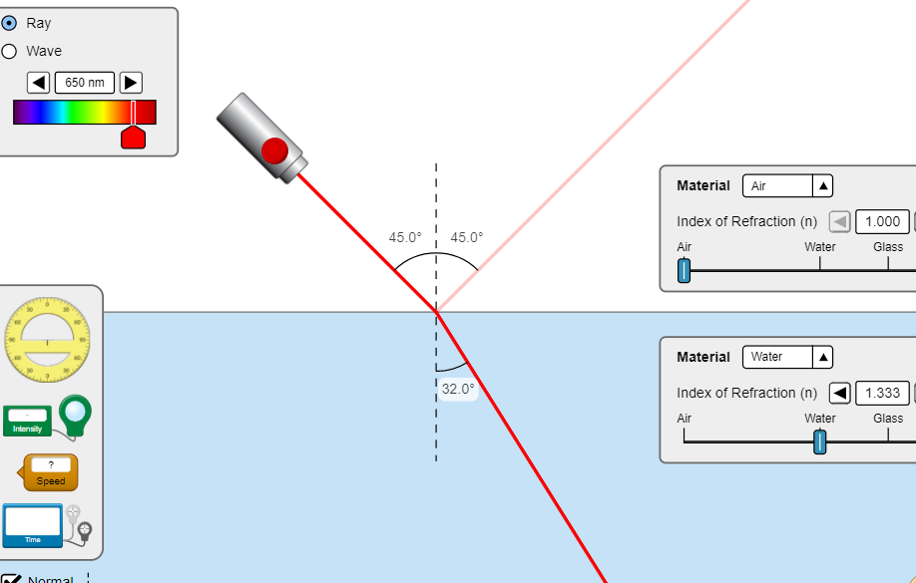

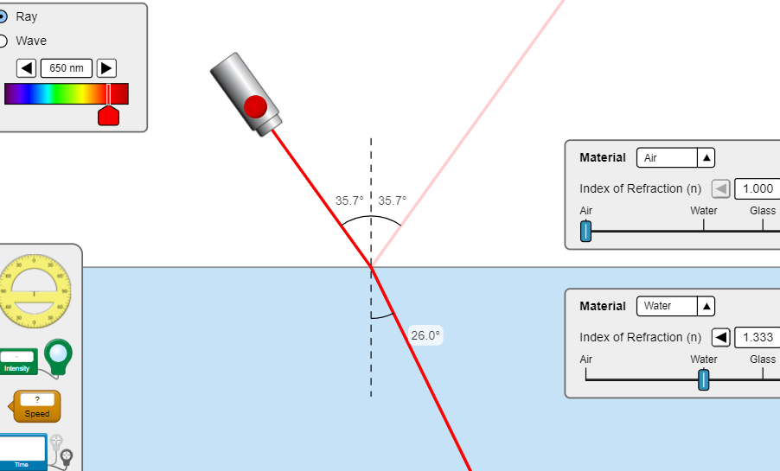

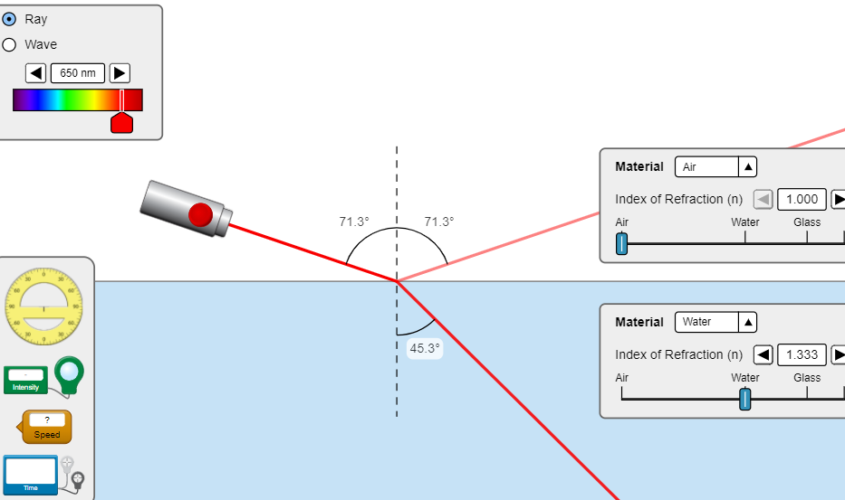

Incident angle | Angle of Reflection | Angle of refraction
45 | 45 | 32
35.7 | 35.7 | 26
71.3 | 71.3 | 45.3

Calculations and Error Analysis:

Air and Glass
Recorded n₂ = 1.5 for glass
Calculated n₂ = $\frac{n1\sin{θ inc}}{sinθrefr}$

Incident angle | Angle of Reflection | Angle of refraction | n₂ = $\frac{n1\sin{θ inc}}{sinθrefr}$
45 | 45 | 28.1 | = $\frac{1\sin{45}}{\sin{28.1}}$ = 4.5905
35.7 | 35.7 | 22.9 | = $\frac{1\sin{35.7}}{\sin{22.9}}$ = 1.15
71.3 | 71.3 | 39.2 | =$\frac{1\sin{71.3}}{\sin{39.2}}$ = 0.82
 |  | Average | = 2.186

Air and water

Incident angle | Angle of Reflection | Angle of refraction | n₂ = $\frac{n1\sin{θ inc}}{sinθrefr}$
45 | 45 | 32 | = $\frac{1\sin{45}}{\sin{32}}$ = 1.54
35.7 | 35.7 | 26 | = $\frac{1\sin{35.7}}{\sin{26}}$ = 1.2
71.3 | 71.3 | 45.3 | =$\frac{1\sin{71.3}}{\sin{45.3}}$ = 0.844
 |  | Average | 1.2

Air and mystery material A

Incident angle | Angle of Reflection | Angle of refraction | n₂ = $\frac{n1\sin{θ inc}}{sinθrefr}$
45 | 45 | 17 | = $\frac{1\sin{45}}{\sin{17}}$ = 0.885
35.7 | 35.7 | 14 | = $\frac{1\sin{35.7}}{\sin{26}}$ = 0.92
71.3 | 71.3 | 23.1 | =$\frac{1\sin{71.3}}{\sin{23.1}}$ = 0.913
 |  | Average | 0.906

Air and mystery material B

Incident angle | Angle of Reflection | Angle of refraction | n₂ = $\frac{n1\sin{θ inc}}{sinθrefr}$
45 | 45 | 30.3 | = $\frac{1\sin{45}}{\sin{30.3}}$ = 0.947
35.7 | 35.7 | 24.6 | = $\frac{1\sin{35.7}}{\sin{24.6}}$ = 1.79
71.3 | 71.3 | 42.6 | =$\frac{1\sin{71.3}}{\sin{42.6}}$ = 0.832
 |  | Average | 1.2

n₂ values for mystery materials A and B are 0.906 and 1.2 respectively

Error analysis
Material | Experimental n | Theoretical n | %error =$\frac{\left(theoretical- Experimental\right)*100\%}{theoretical}$
Glass | 1.5 | 2.186 | 31.4%
Water | 1.33 | 1.2 | -10.83%

Conclusion:
The refractive index values for mystery materials A and B were determined as 0.906 and 1.2 respectively. The % error for glass material is 31.4% and that of water is -10.83%. The %error proves that there were some inconsistency with our experiment caused perhaps by random errors.

